Lecture 21

CPSC 131

11/11/2020

924 6951 7663

1. Project 4
   1. TODO1 BookStore.cpp  
      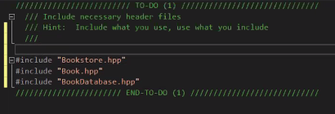  
      Don’t forget  
      #include <fstream>
   2. TODO2  
      no fstream (maybe, it’s just a while loop with a >>)
   3. TODO3
      1. For each shopping cart  
           
         **for(auto i=shoppingCarts.cbeing();i!=shoppingCarts.cend();++i){  
         const auto & name = i-> first;  
         const auto & cart = i-> second;  
         } //<-This one was really popular**  
           
         or  
           
         for( auto & [name,cart] :shoppingCarts){}  
           
         or  
           
         for(const auto & pair: shoppingCarts)  
         {  
         const auto & name = pair.first;  
         const auto & cart = pair.second;  
         }
      2. Initialize the amount due to 0  
         double amountDue = 0.0;
      3. For each book in the customer’s shopping cart  
         for(auto i=cart.cbeing();i!=cart.cend();++i){  
         const auto & isbn = i-> first;  
         const auto & book= i-> second;  
         }
         1. If book not found in database  
            auto fullItemDescription = worldWideBookDatabase.find(isbn);  
            if (fullItemDescription == nullptr){  
            //not found  
            std::cout<<”<<sibn<<”\” (“<<book.title()<<”)note found, the book is free!\n”;  
            }
         2. Otherwise  
            {
         3. Print full description  
            std::cout<< fullItemDescription<<’\n’;
         4. Add book price t amount due  
            amountDue += fullItemDescription->price;
         5. If book something store sells

Auto stockedItem = _inventoryDB.find(isbn);  
if(stockItem !=_inventory.end())  
{

* + - * 1. Decrease number of books on hand for book sold  
           //part of last part’s if statement  
           --stockedItem->second;
        2. Add book’s isbn to list of books sold today  
           //part of 1.3.3.5’s if statement  
           todaysSales.insert(isbn);  
            }  
           }
    1. Print total to receipt  
       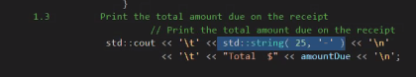t  
       }  
       }

1. Friday Office Hours
   1. What time?